Retouching

- You need a head and shoulders type portrait to work with (preferred).

- You should be looking mostly at the camera

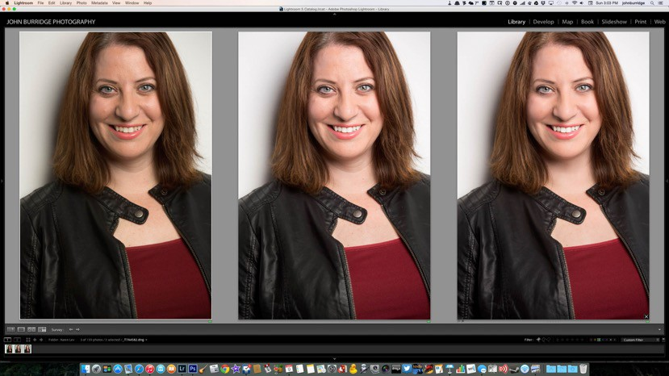

Portrait Retouching
Camera - Bridge/Lightroom - Photoshop

Raw File Adjustments in ACR or Lightroom
Liquefy
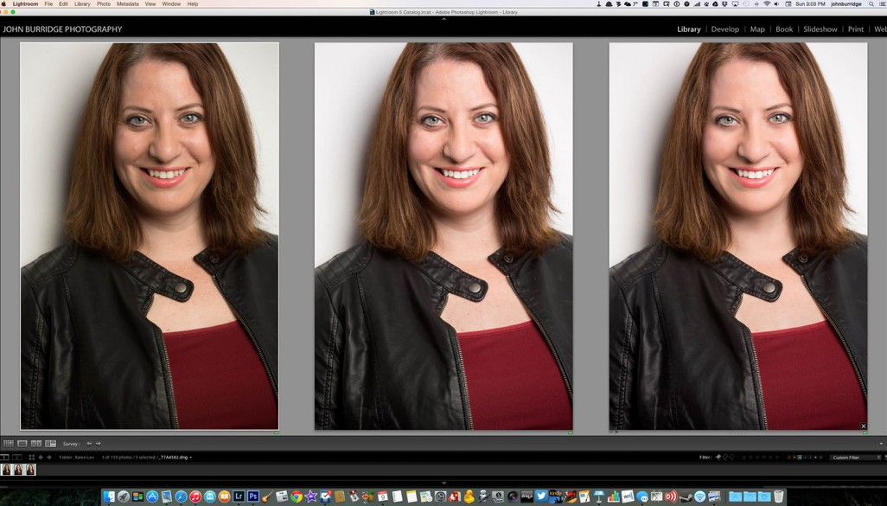
Skin smoothing Contrast
Stray Hairs

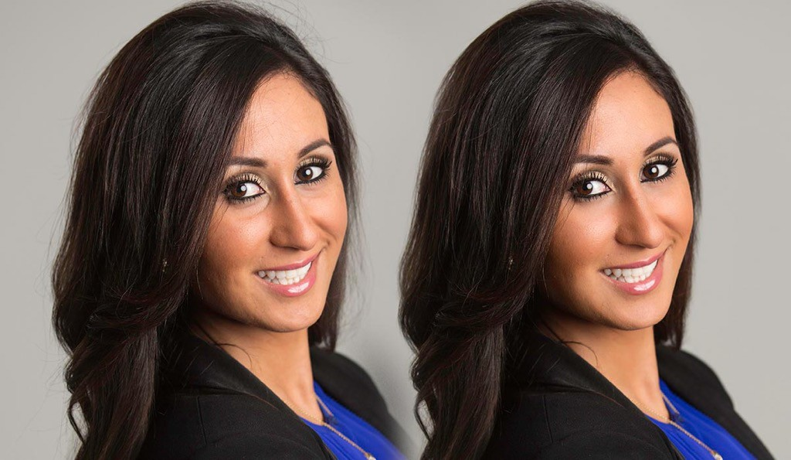
Another retouching example

Retouching techniques for today
- Liquefy Tools

- Blemish removal (demoed )

- Wrinkle smoothing or removal (Healing and Cloning)

- Stray hair removal (Cloning)

- Teeth whitening (Hue/Saturation)

- Skin smoothing

- For your assignment, use 2 of the 6 techniques here

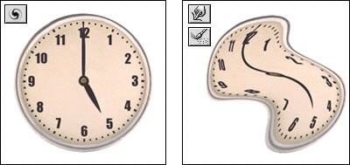
Liquefy tools

  - We’ll deal mostly with the Warp tool and the Freeze tool

  - Warp(w) moves pixels around

  - Freeze(f) (and Thaw) help you mask off what doesn’t get affected

When to use Liquefy

- Minimize bulges

- Double chins

- Rumpled clothing…

- Reduce features enhanced by wide angle lens

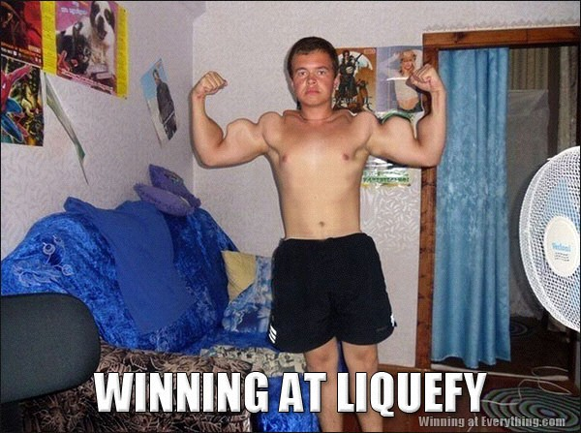

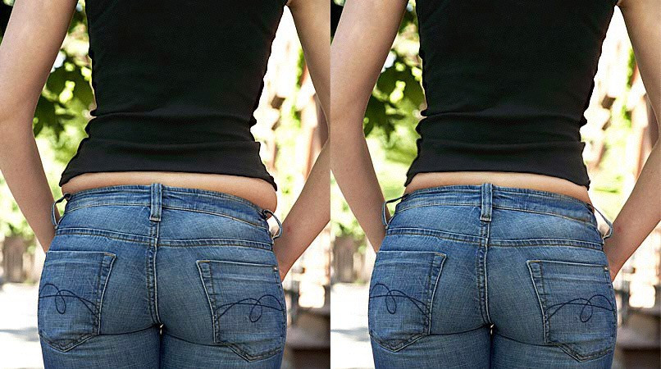

More realistic use, but not for everyday…

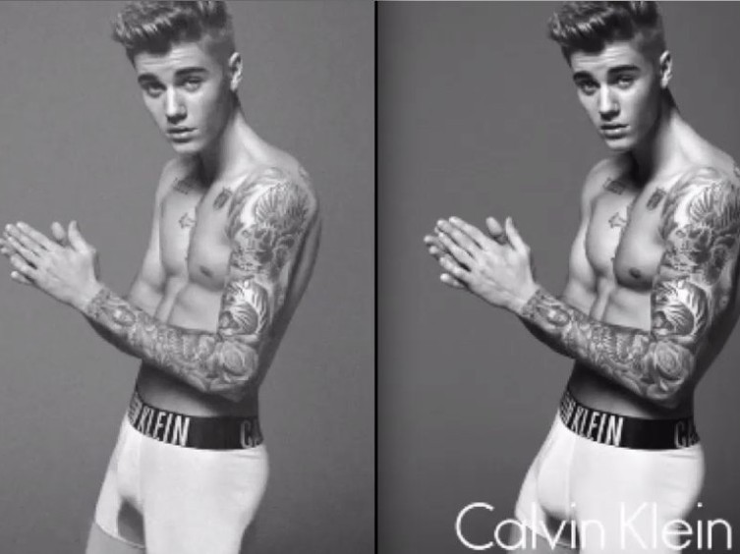

Recently…

The Liquefy Editing Space
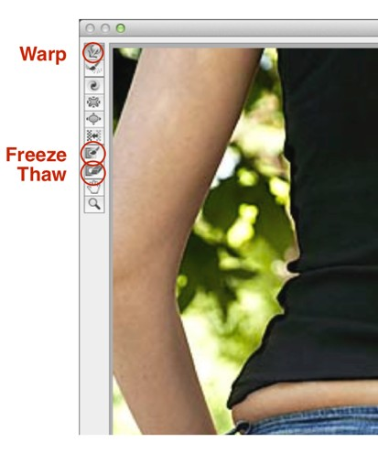
- Hitting Cmd+Shift+X or choosing Filter
->Liquefy… gets you in the Liquefy editing space

- Always work on a copy of your layer

- Warp pushes the pixels around

- Freeze protects areas you want unchanged

- Thaw “unfreezes” that area, in case you want to then Warp it

- Check and uncheck the Show Mask box to see frozen and unfrozen areas

- Use a bigger brush than you might expect to move things around

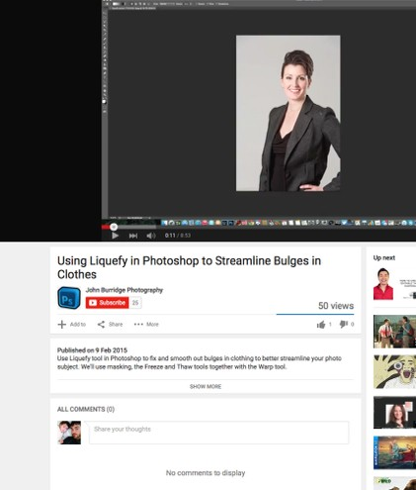
Liquefy for clothing…

- Video recap of using Liquefy to smooth and redefine lines in clothing: https://youtu.be/ clwOlbRRQx8

Wrinkle smoothing, blemish removal

Healing brush is best for blemishes

- For wrinkles, Healing brush or Clone stamp set to Lighten mode works best

- Always work on a new layer

- Make sure your Healing Brush is affecting all layers

- Video demo: https://youtu.be/1TWuPEakKg4

Main Workflow
- Create a new layer

- Select your Healing brush (affect all layers)

- Clone from a nearby area of skin (option-click) that is smooth or blemish free

- Brush onto area to be concealed

- Reduce the opacity of your layer to bring back some of the original texture (unless it’s acne)

Teeth Whitening
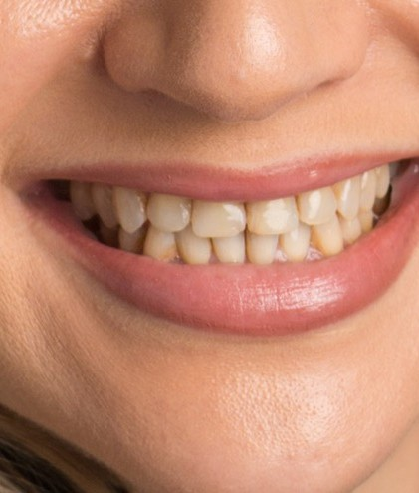
- Most people’s teeth are more yellow than they’d like

- We’ll use the Hue/Saturation Adjustment layer to affect the Yellows, and sometimes the Reds

- Will have to mask off the areas we don’t want affected

- Be careful not to completely desaturate the teeth or

- over-brighten them... which becomes fake

- recap: https://youtu.be/LlSdbmZ7K0o

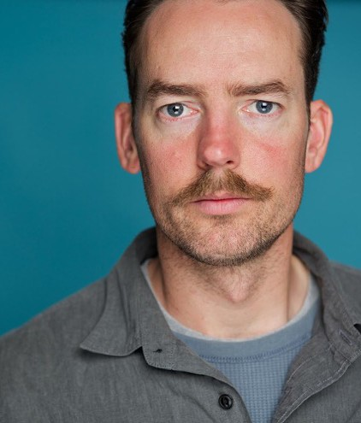
Fixing Blotchy Skin

- Redness is usually what we’re out to fix here, but yellowness is often a consideration, too

- Most of the work is done in a Hue/Saturation layer where we try to isolate the redness from the other skin tones

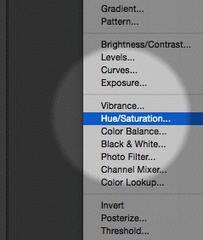
Red Skin fixes…

- Create a new Hue/Saturation Adjustment Layer

- Move down to the Reds (Option-3) to start isolating the Reds

- Use the “+ Eyedropper” Tool to hone in on reds, then use the “- Eyedropper” Tool to protect the area of skin you don’t want to change

Red Skin Fixes…
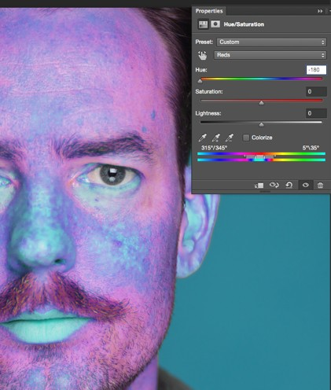
- Drag your Hue slider all the way to the left to exaggerate the skin colours

- The most vivid blue areas will be the areas most affected

- The more purple areas show where your adjustment will have some effect, but much less than the vivid blue areas

- We will then hone in even further to isolate the red area

Red Skin Fixes…
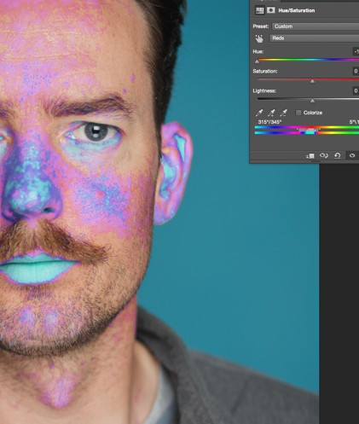
- Drag the special targeting tool to the right to narrow your range of red

- Watch as less of the skin is affected

- Once you’re satisfied with what will be affected, slide the Hue slider back to zero, and then start moving it to the right

- Redness will move to the yellows, and adjust to taste

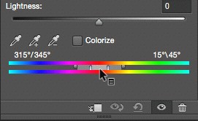
Select the reddest part in the image with the
✛ Eyedropper tool

Drag the rightmost slider to narrow the range of red that you’ll be affecting

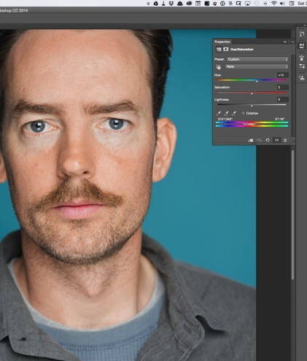
Red Skin Fixes…

- In this case, the Hue slider was dragged to +14 due to major sunburn

- Remember to mask off effect from lips or anything else that is red in the image that might be affected

- Video recap: http://youtu.be/ 6Xu3c0KKhT4

Softening Skin
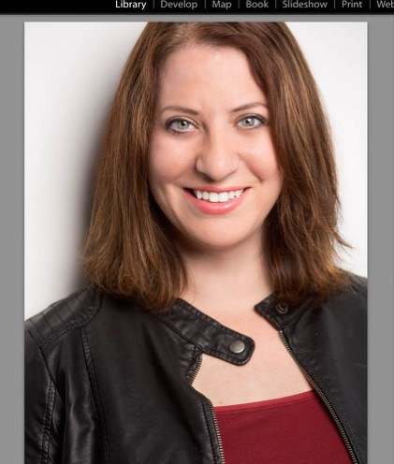
- Great for evening out blotchy or shiny skin

- Usually a final stage, once you’ve removed blemishes and softened wrinkles

- Many different ways to smooth out skin, each has advantages and disadvantages

- Numbers, settings are dependent on how much skin is at the forefront of the image

Steps to skin softening
- Copy everything you’ve done to your image so far up to its own layer by selecting the top layer and hit Cmd+Option+Shift+E

Repeat the same shortcut again to make another copy Cmd
+Option+Shift+E. Name this topmost layer something like "Blur"

Making sure the top, "Blur" layer is selected, go to Filter -> Blur
-> Surface Blur. In the case of our image, choose Radius of 39 and Threshold of 31

- Also make sure your blurred layer is set to 50% Opacity

- But first, a word on blurring…

Kinds of Blur…

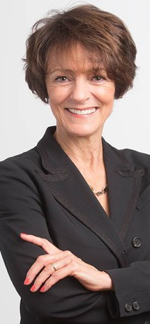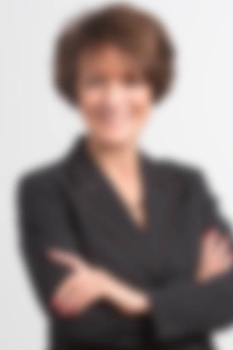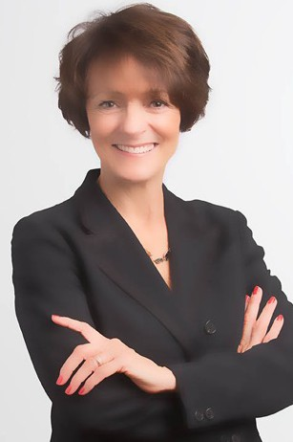

No Blur Gaussian Blur, Radius 39 blurs “everything”
Surface Blur, with similar settings, respects edges but blurs inside each area

Surface Blur Settings
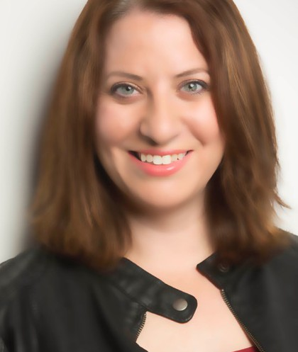
- Radius: The higher the Radius value, the more blurring gets applied

- Threshold: A value of zero means next to no blurring will get applied. Photoshop will think everything is an edge and will not identify any common areas to blur.

  - Increase the Threshold value to start seeing an effect but stop before your true edges start to blend with each other

High Pass Filter
- You'll remember that we made 2 copies of our "up-flattened" layers

- The other, non-blurred layer should be called something like "Texture"

- Run a High Pass filter on this Texture layer, usually to a value between 4 and 5. Your layer will look gray-ish and bumpy

- You will then set the blending mode of this layer to Soft Light

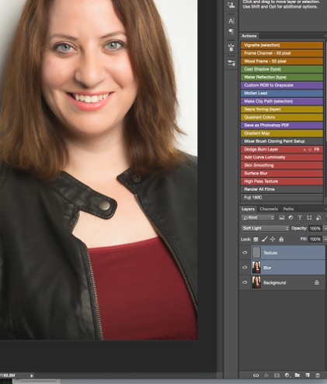
Put your layers in a Group folder
Group folder

- The next thing we want to make sure of is our Texture layer is above our Blur layer

- Shift-select your 2 layers, and then hit the Group icon in your layers palette

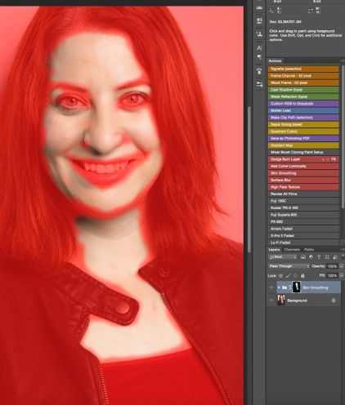
Add a mask to your group

- We then want to add a mask pre-filled with black to it, so hold the Option or Alt(PC) key and hit the Add Layer Mask icon in your layers palette

- We next want to brush back in to our black mask (using white) to apply the skin blurring effect only where we want it

To get this view, hit the"\" key

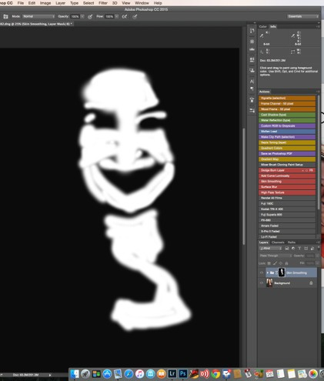
black and white mask view

- Video Recap: http://youtu.be/ 8vZJ9uYQxAQ

- (recap is a little different, uses a more complicated method of masking, but is overall the same technique)

To get this view, Option-click in your mask's thumbnail

Stray Hairs
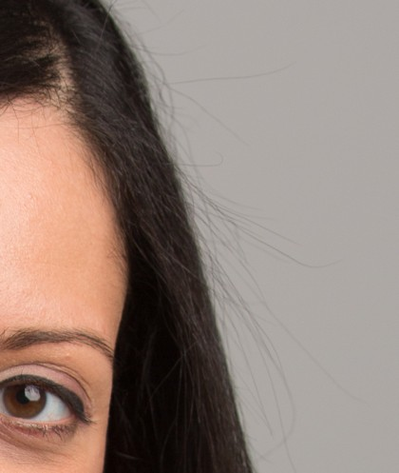
- Clone Stamp, rather than Healing Brush, is your best tool

- Against lighter backgrounds, set your Clone Stamp to Lighten mode, but will depend on case by case

- Always work on a new layer

- Use Polygonal Lasso tool to outline around person's head to protect it, then use Clone Stamp tool to cover up fly- aways

Exception for Stray Hairs

- Use the Healing Brush (instead of Clone Stamp) for hairs that are against skin that need to be cleaned up (usually forehead area)

- In other words, if the background has texture, you’re probably better off with the Healing brushes

